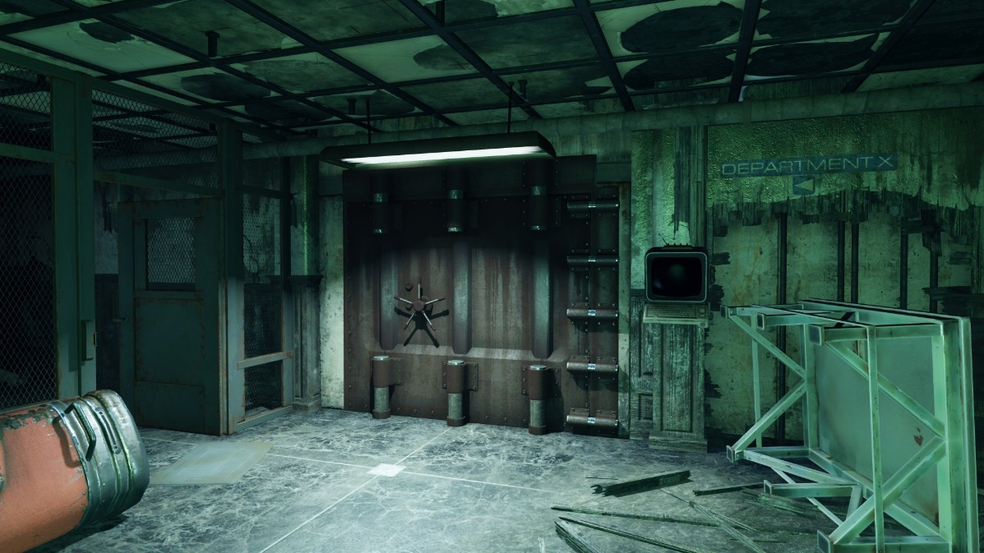

Figure : Visual Reference for Utility Tunnels [1]

*Fallout 4:*   
“Meltdown”

Version 1.0

|  |  |
| --- | --- |
| Designer: | Jake Patton |
| Document Date: | 12/3/2017 |

**Document Revisions Table**

|  |  |  |
| --- | --- | --- |
| **Version** | **Description** | **Date** |
| 1.0 | Initial Document |  |
| 1.1 | Map Updates | 1/17/2018 |
| 2.0 | Map Updates and Context Reformatting Based on OneNote Documentation | 4/5/2018 |
|  |  |  |
|  |  |  |

# Table of Contents

Table of Contents 2

Table of Figures 2

Level Information 3

Level Goals 3

Quick Summary 3

Design Levers 4

Used Design Levers 4

Scene Table 5

Maps 7

Scene 1 7

Scene 2 13

Scene 3 15

Objective(s) 18

Hook(s)/Gameplay Highlights 18

Production Requirements 19

New Gameplay Mechanics 19

Development Schedule 19

Requirements 19

References 20

# Table of Figures

Figure 1: Visual Reference for Utility Tunnels [1] 1

Figure 2: Scene 1 – Basement (Start) 7

Figure 3: Basement (Boiler Rooms) 8

Figure 4: Scene 1 - Ground Level 9

Figure 5: Scene 1 - Top Level 10

Figure 6: Raider Caves 11

Figure 7: Scene 2 – Exterior 13

Figure 8: Scene 3 - Exterior 15

Figure 9: Scene 3 – Interior 16

Level Design Document

# Level Information

## Level Goals

1. To demonstrate the application of my process for using Game Feel to align player interaction with game metaphor.
2. To create a *Fallout 4* of portfolio quality.

## Quick Summary

“Meltdown” is a single player level for *Fallout 4* in which the player attempts to find and destroy the nuke worshiped at a raider camp inside of an old military research base using a special set of pre-war power armor. To communicate the player’s arc, from confinement to power to their near defeat, “Meltdown” uses my thesis process to align player interaction with game metaphor. In keeping with this, the level focuses on telling its story through the gameplay experience of the player rather than explicit narrative told through dialog. The player begins in the basement of the inner base, armed only with a shotgun. They face hordes of Raiders as they ascend to the raider town in front of the complex to find the nuke. Unfortunately, when the player reaches the machine that will destroy the nuke for good, their power armor is damaged and they are forced to face the raiders without it as they hold out for the nuke to be completely destroyed.

## Design Levers

|  |  |  |  |
| --- | --- | --- | --- |
| **Verb/Level Design Element** | **Exposed Variables** | **Filter** | **Tone Shapes** |
| **Move** | Movement Speed | Control / Intensity / Freedom | Circle / Square |
|  | Game Speed | Intesity / Control | Circle / Triangle |
|  | Power Suit | Control / Freedom / Identification | Square |
|  | Level Openness (LD) | Freedom | Circle / Square |
| **Look** | Power Suit | Control / Freedom / Identification | Square |
|  | Number of Enemies (LD) | Intensity | Circle / Triangle |
|  | Amount of Cover (LD) | Intensity / Freedom | Square / Triangle |
|  | First / Third Person | Association / Control | Circle / Square |
| **Aim** | Power Suit | Control / Freedom / Identification | Square |
|  | Player Has High Ground (LD) | Control / Freedom | Circle / Square |
|  | VATs | Control / Intensity | Cicle / Square / Triangle |
| **Shoot** | Gun RoF | Control / Intensity | Circle / Square |
|  | Gun Damage | Control / Intensity | Circle / Triangle |
|  | Gun Feedback | Control / Identification | Circle / Triangle |
|  | Enemy Health (LD) | Freedom / Control / Intensity | Circle / Square |
| **Punch** | ? Player Strength ? | ??? | X |
|  | Power Suit | Control / Freedom / Identification | Square |
| **Survive** | Enemy Damage (LD) | Freedom / Control / Intensity | Circle / Triangle |
|  | Player Health / Availability of Health Items (LD) | Freedom / Intensity / Control | Square / Triangle |
| **Pick Up** | X | X | X |
| **Talk** | X | X | X |
| **"Interact"** | X | X | X |

Table : Fallout 4 Game Feel Lever Table

### Used Design Levers

* Power Suit
* Gun Type (RoF, Damage, Feedback)
* Movement Speed
* Number of Enemies
* Enemy Difficulty (Enemy Health + Damage)
* Amount of Cover

## Scene Table

|  |  |  |
| --- | --- | --- |
| Scene 1 | Scene 2 | Scene 3 |
| In Control / Constraint | In Control / Freedom | Constraint / Out of Control |

Table : Game Feel Filter By Scene

|  |  |  |  |
| --- | --- | --- | --- |
|  | **Levers** | **Call to Action** | **Rising Tension** |
| **Scene 1** | In Control / Constrained | Square | Triangle |
| **Scene 2** | In Control / Free | Circle | Circle |
| **Scene 3** | Out of Control / Constrained | Square | Triangle |

Table : Tone Shapes by Scene

|  |  |  |
| --- | --- | --- |
| Scene 1 | Scene 2 | Scene 3 |
| **In Control**   * low enemy damage + number + health * high player health * lots of cover * constant forward momentum through level   **Constrained**   * Small spaces * short range weapon * slow firing weapon * short lines of sight * lots of cover * use of flanking and choke point enemy placement patterns | **In Control**   * low enemy damage + health * high player health * high player movement speed * use of arena enemy placement patterns * high weapon range + damage * constant forward momentum through level   **Free**   * high player movement speed * use of arena enemy placement patterns * high weapon range + damage * low enemy cover * open spaces * long sight lines * fast level flow | **Out of Control**   * high number of enemies * low player health (lose power suit) * lower player movement speed * Use of stronghold and choke point enemy placement patterns * Low weapon damage * Stationary, wave-defense level structure   **Constrained**   * Stationary, wave-defense level structure * Low player movement speed * Use of stronghold and choke point enemy placement patterns * High enemy and player cover * Enclosed spaces * Short sight lines * Constrained level flow |

Table : Mechanics Modified by Scene

# Maps

## Scene 1

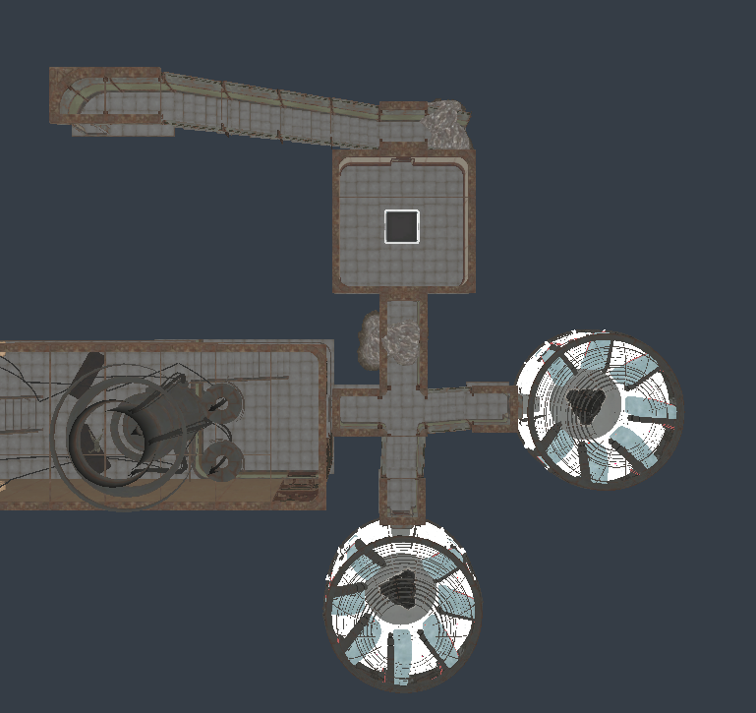

256

256

**1**

**2**

**3**

Figure : Scene 1 – Basement (Start)

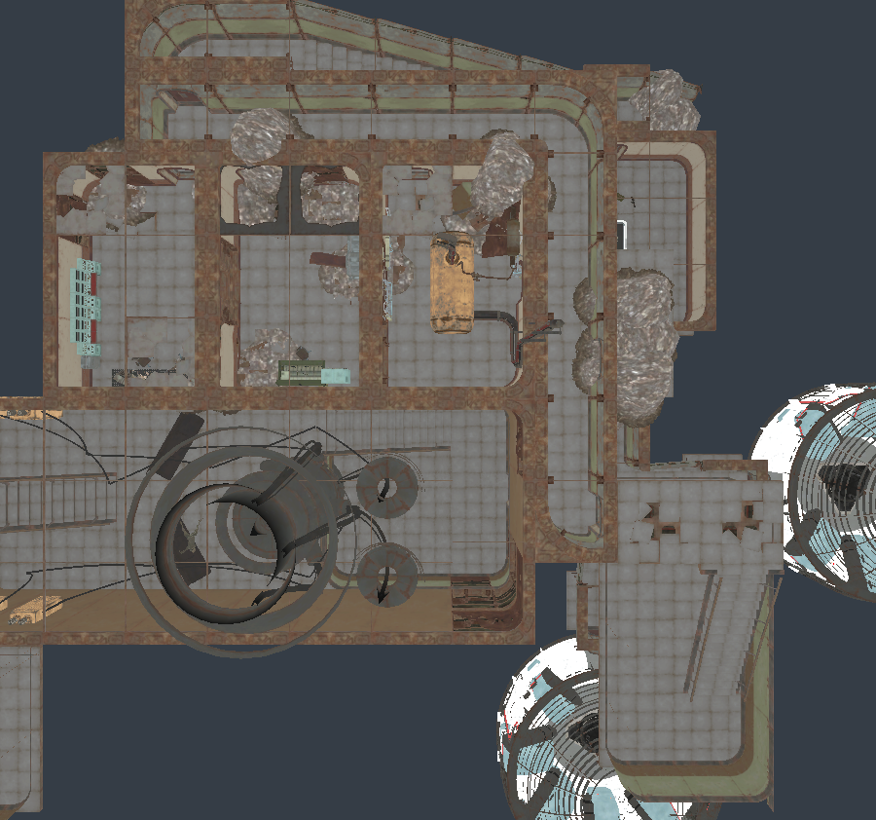

256

256

**B**

**6**

**4**

**A**

**5**

Figure : Basement (Boiler Rooms)

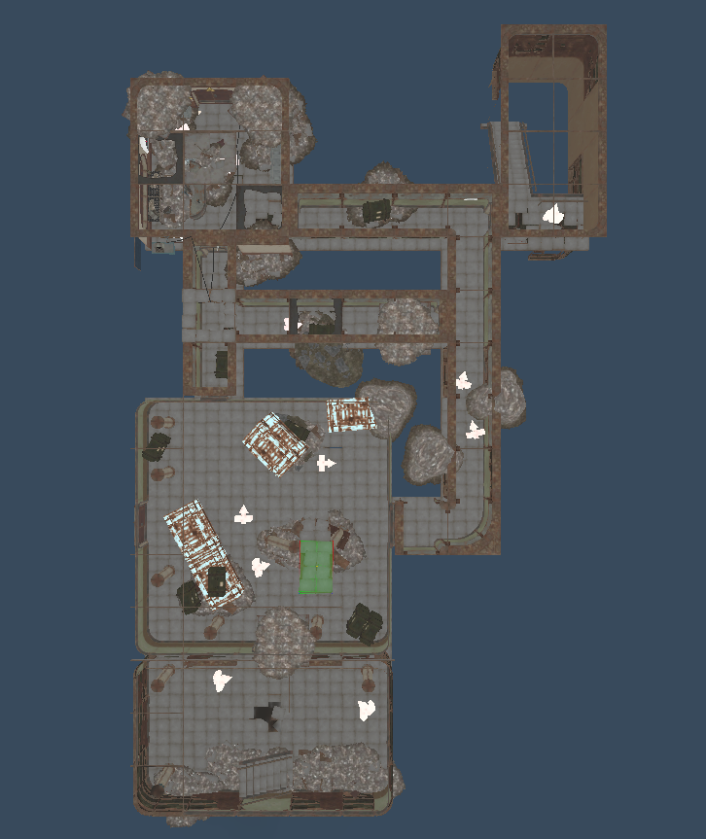

256

256

**13**

**12**

**C**

**7**

**8**

Figure : Scene 1 - Ground Level

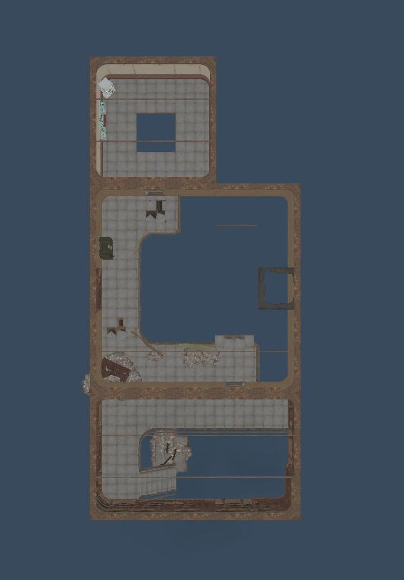

256

256

**11**

**10**

**D**

**9**

Figure : Scene 1 - Top Level

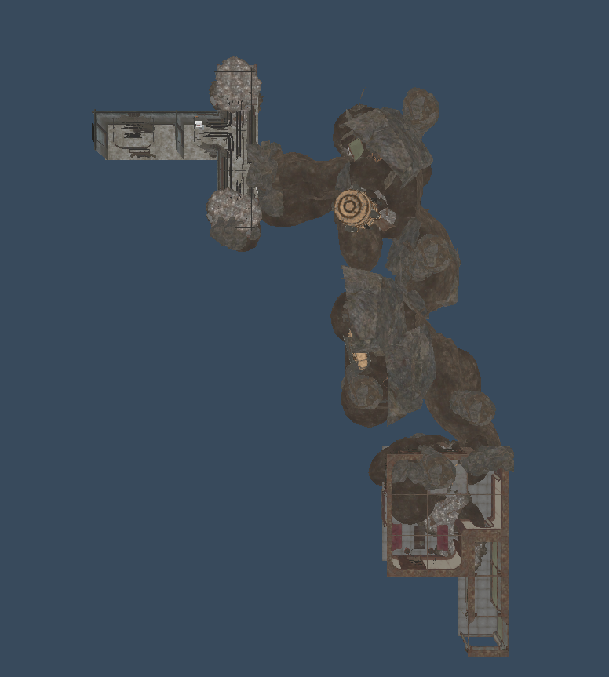

256

256

**E**

**16**

**15**

**14**

**F**

Figure : Raider Caves

|  |  |  |  |
| --- | --- | --- | --- |
| Map Label | Location Description | Detail Information | Wow? |
| 1 | Player Starting Teleporter | Player begins level in teleporter Room | No |
| 2 | Player Acquires Power Armor | In room across from teleporter | Yes |
| 3 | Exit to Basement 1 | -- | No |
| 4 | Player Enters Basement 1 | --- | No |
| 5 | Player Talks to Albert | Sees Dematerializer, hears about next steps of quest, door unlocks | Yes |
| 6 | Exit to 1st Floor | --- | No |
| 7 | Player Enters 1st Floor | Enemy spawns draw player to side room | No |
| 8 | Exit to Top Floor | --- | No |
| 9 | Player Enters Top Floor | Enemies draw player to terminal room | No |
| 10 | Activates door | Turns off wire, opens door to continue | No |
| 11 | Hole to Bottom Floor | Player drops to 1st floor | No |
| 12 | Player Re-Enters 1st Floor | Wire draws player to door | No |
| 13 | Exit to Caves | --- | No |
| 14 | Player Enters Caves | --- | No |
| 15 | Player Talks to Albert Again | Tells player about next quest step | No |
| 16 | Exit to Scene 2 | --- | No |

Table : Scene 1 Progression Summary

|  |  |  |  |  |
| --- | --- | --- | --- | --- |
| Map Label | Encounter Name | Encounter Type | Detail Information | Approx. Difficulty (1-10) |
| A | Initial Hallway | Choke Point / Flanking Route | Enemies at end of hall can be overcome by flanking through side rooms | 3 |
| B | Stair Assault | Stronghold / Hallway | Player fights a handful of enemies up two flights of stairs | 5 |
| C | Long Hallway | Choke Point / Flanking Route | Like initial hallway, but hallway is longer and flanking route is more dangerous | 4 |
| D | Two Floor Assault | Stronghold | Player fights up to high ground enemies | 5 |
| E | Tunnel Hallway | Hallway | Intentionally break design rule-of-thumb against single-direction enemy hallway to increase tension | 5 |
| F | Miniboss | Hallway | Long narrow hall with laser gatling | 7 |

Table : Scene 1 Encounter Summary

## Scene 2

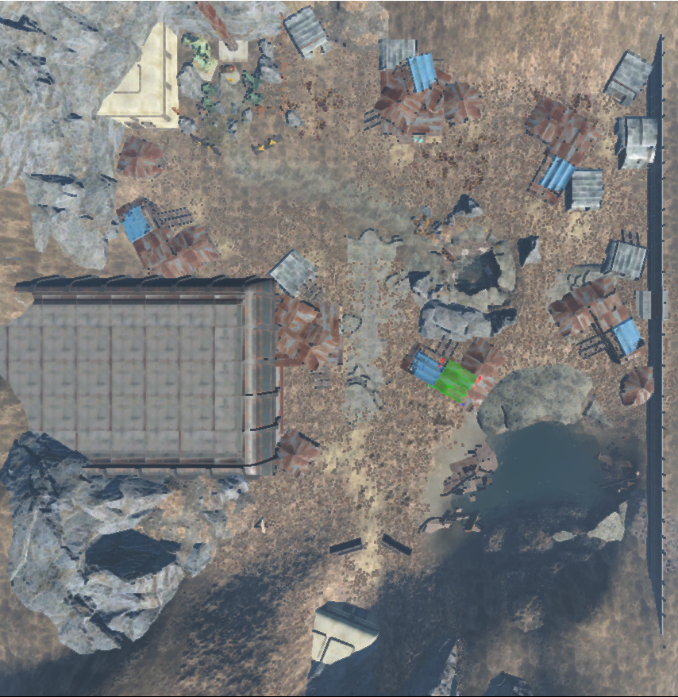

**A**

**B**

256

256

**3**

**2**

**1**

Figure : Scene 2 – Exterior

|  |  |  |  |
| --- | --- | --- | --- |
| Map Label | Location Description | Detail Information | Wow? |
| 1 | Exit to Exterior | --- | Yes |
| 2 | Center of Courtyard | Player goes to the center of the courtyard, fighting enemies, sees bomb | No |
| 3 | Getting Bomb | Player gets bomb, Next Door Opens | Yes |

Table : Scene 2 Summary

|  |  |  |  |  |
| --- | --- | --- | --- | --- |
| Map Label | Encounter Name | Encounter Type | Detail Information | Approx. Difficulty (1-10) |
| A | Open Field | Arena | Player has an incredibly powerful weapon but faces lots of enemies in an open area with clumps of cover | 4 |
| B | Defense of Switch | Arena, Stronghold | Enemies holding a defensive point near the final switch, relatively small numbers | 3 |

Table 6: Scene 2 Encounter Summary

## Scene 3



256

256

**2**

**1**

Figure : Scene 3 - Exterior

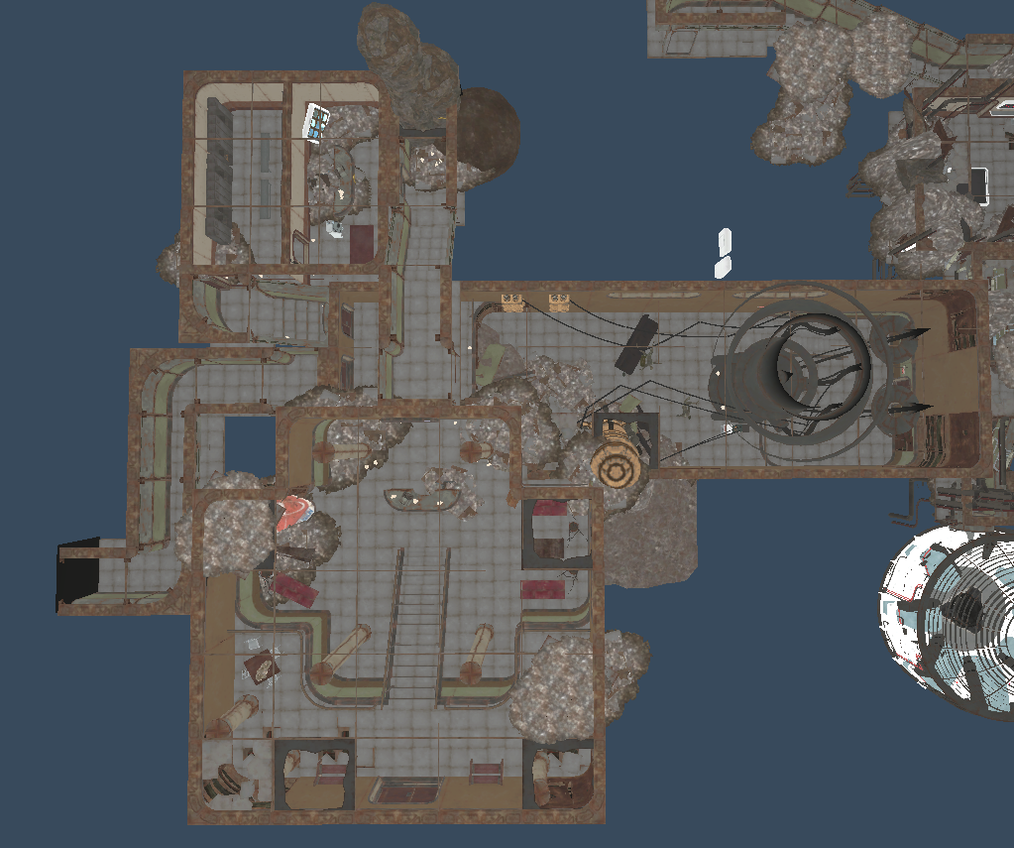

256

256

**A**

**7**

**5**

**6**

**4**

**3**

Figure : Scene 3 – Interior

|  |  |  |  |
| --- | --- | --- | --- |
| Map Label | Location Description | Detail Information | Wow? |
| 1 | Player Retrieved Bomb | --- | No |
| 2 | Entrance to Interior | --- | No |
| 3 | Player Enters Interior | --- | No |
| 4 | Player Travels Through Decontam. Rooms | Ruins of old protocol for entering demat. Room | No |
| 5 | Player Talks to Albert 3 | Explains Defense, Defusing, Asks if player ready. | No |
| 4 | Player Defends Defusing Bomb | Albert places bomb in the defuser, Power Armor destroyed by EMP, player finds pistol and ammo, must defend against waves of enemies until the door opens | Yes |
| 5 | Player Exits | Player escapes, exits through the rear of the garage | Yes |

Table : Scene 3 Summary

Table : Scene 3 Encounter Summary

|  |  |  |  |  |
| --- | --- | --- | --- | --- |
| Map Label | Encounter Name | Encounter Type | Detail Information | Approx. Difficulty (1-10) |
| A | Defense | Reverse Stronghold | Player has full cover but enemies have high ground | 7 |

|  |  |  |  |
| --- | --- | --- | --- |
| Wave Number | Wave Composition | Approx. Difficulty (1-10) | Approx. Time |
| 1 | 3x Random Raider - Easy | 6 | 8:00 |
| 2 | 3x Random Raider – Medium | 7 | 8:30 |
| 3 | 3x Random Raider – Hard | 7 | 8:45 |
| 4 | 3x Random Raider – Hard | 7 | 8:45 |
| 5 | 2x Random Raider –Medium 1x Boss Raider – Hard | 8 | 9:15 |

Table : Scene 3 Wave Composition (TBD)

## Objective(s)

* Defuse the bomb the raiders worship
* Survive

## Hook(s)/Gameplay Highlights

* Three distinct scenes, each with their own gameplay feel including
  + Claustrophobic corridor shooting
  + An open Gatling gun-focused area
  + A final defense section

# Production Requirements

## New Gameplay Mechanics

* Power Armor breaking down on command
* Slowly opening door (or some other countdown for the door)

## Development Schedule

|  |  |
| --- | --- |
| Milestone | Date |
| LDD | 1/22/2018 |
| Whitebox | 2/5 |
| Gameplay (Core) | 2/12 |
| First Test Run | 2/19 |
| Iterate on Feedback 1 | 2/26 |
| Second Test Run | 3/5 |
| Gameplay (Refined) | 3/19 |
| Aesthetics | 4/2 |
| RTM | 4/9 |

## Requirements

|  |  |  |  |
| --- | --- | --- | --- |
| Map Label | Description | Type | Priority |
| 2 (Interior) | Secret door | Scripting | Low |
| 2 (Exterior) | Enemy Attack Waves | Scripting | Medium |
| 5 (Exterior) | Destroying Power Armor | Scripting / Aesthetics | High |
| Scene 3 | Slowly opening door | Scripting | High |

# References

[1] <http://fallout.wikia.com/wiki/The_Switchboard>