Arcana

Design Document

v1.0

|  |  |  |
| --- | --- | --- |
| Version | Date | Changes |
| 1.0 | 6/5 | Created Document |
| 1.1 | 6/12 | Adjusted tables to reflect current values  Detailed gambling mechanics as detailed |
| 1.2 | 6/13 | Added additional enemy type (ranged) |
|  |  |  |

Contents

[Table of Figures 2](#_Toc487636173)

[Overview 3](#_Toc487636174)

[Combat 3](#_Toc487636175)

[Controls 3](#_Toc487636176)

[Player Statistics 3](#_Toc487636177)

[Enemies 3](#_Toc487636178)

[Waves 3](#_Toc487636179)

[Enemy Level 3](#_Toc487636180)

[Pickups 3](#_Toc487636181)

[Enemy Statistics 4](#_Toc487636182)

[Score 5](#_Toc487636183)

[Upgrades 5](#_Toc487636184)

[Cards 5](#_Toc487636185)

[Overview 5](#_Toc487636186)

[Buying Packs 5](#_Toc487636187)

[Single Card Packs 5](#_Toc487636188)

[Multiple Card Packs 6](#_Toc487636189)

[Card Costs 6](#_Toc487636190)

[Card Effects 6](#_Toc487636191)

[The End of the Game 6](#_Toc487636192)

[UI/HUD 6](#_Toc487636193)

[HUD 6](#_Toc487636194)

[Appendix A – Card Effects 7](#_Toc487636195)

# Table of Figures

[Figure 1: Control Table 4](#_Toc487636156)

[Figure 2: Player Statistics Table 4](#_Toc487636157)

[Figure 3: Basic Enemy Statistics Table 5](#_Toc487636158)

[Figure 4: Ranged Enemy Statistics Table 5](#_Toc487636159)

[Figure 5: Upgrade and Gambling Table 6](#_Toc487636160)

[Figure 6: Card Pack Cost Table 7](#_Toc487636161)

[Figure 7: HUD Concept 7](#_Toc487636162)

# Overview

*Arcana* is a economic Shoot’em Up in which the player’s goal is to achieve the top score possible by killing enemies and betting their own weapons/health to get a better score multiplier. Each wave, the player is able to buy powerful cards, which come with a game-changing effect, either positive, negative, or both. After **30 waves** the player completes the game, and their score is graded from S to D. The goal of the game is to have the highest score after this period.

# Combat

## Controls

|  |  |  |
| --- | --- | --- |
| Action | Control | Details |
| Move | Left Analog Stick / WASD | N/A |
| Shoot | Right Analog Stick / Arrow Keys | N/A |

Figure 1: Control Table

## Player Statistics

|  |  |
| --- | --- |
| Statistic | Value |
| Base Health | 3 |
| Invulnerable Time | 0.5 seconds |
| Movement Speed | 5 |
| Attack Speed | 4 / second |
| Base Attack Damage | 1 |

Figure 2: Player Statistics Table

# Enemies

## Waves

Enemies spawn in waves separated by a period in which the player can upgrade their statistics and/or gamble their statistics. These waves increase in difficulty, either in the number of enemies spawned, or the enemies level.

Each wave will have a given maximum amount of enemy health in them. This amount **increases by 1 for each wave**. Ranged enemies’ **fire cooldown decreases by 0.1 for each level**, to a minimum of .25 for each level. At the beginning of each wave, the enemies wait **1 second** before moving or attacking. During this time, the player is immobile and unable to shoot as well.

## Enemy Level

Higher level enemies have more health but reward more score. **Each level gives the player 1 more health and 10 more score.**

## Pickups

When killed, enemies may drop a health pickup, which the player can walk over to recover 1 health. The player can never recover health above their maximum health.

## Enemy Statistics

|  |  |
| --- | --- |
| Statistic | Value |
| Base Enemy Health | 2 |
| Base Enemy Score | 10 |
| Base Enemy Health Drop % | 2.5% |
| Health / Level | 1 |
| Score / Level | 10 |
| Health Drop % / Level | 3.5% |
| Damage to Player on Contact | 1 |

Figure 3: Basic Enemy Statistics Table

|  |  |
| --- | --- |
| Statistic | Value |
| Base Enemy Health | 2 |
| Base Enemy Score | 15 |
| Base Enemy Health Drop % | 3% |
| Health / Level | 1 |
| Score / Level | 15 |
| Health Drop % / Level | 4% |
| Damage to Player on Contact | 1 |
| Base Projectile Cooldown | 1.5s |
| Cooldown Subtracted Per Level | 0.1s |
| Minimum Cooldown | 0.25s |
| Projectile Speed | 8.0 |

Figure 4: Ranged Enemy Statistics Table

# Score

The player gains score when they kill an enemy. When the player dies, their current score is recorded as the final score for that game. The game ends after **30 waves**. After completing all 30 waves, the player receives a flat score bonus of .

## Upgrades

The player can spend score to upgrade their maximum health or weapon damage after each wave. The amount of score needed to purchase an upgrade increases with each upgrade bought of any type bought but increases more per level of that upgrade

The player can sacrifice their health and/or weapon damage for a wave. After the wave is completed, they receive a score bonus depending on the amount of score gained in that time and the health and/or weapon damage is returned.

|  |  |
| --- | --- |
| Statistic | Value |
| Additional Damage / Weapon Upgrade | 1 |
| Additional Health / Health Upgrade | 1 |
| Base Upgrade Cost: Health | 25 |
| Base Upgrade Cost: Weapon | 50 |
| Additional Cost / Global Level | 25 |
| Additional Cost / Upgrade Level | Base Cost \* Upgrade Level2 |
| Score Multiplier Bonus Per Health Upgrade Gambled | .5x |
| Score Multiplier Bonus Per Weapon Upgrade Gambled | 1x |

Figure 5: Upgrade and Gambling Table

# Cards

## Overview

After every round, the player is given the opportunity to buy “packs” of effect cards based on the Major Arcana of the Tarot Deck. Most of these cards give a powerful positive effect as well as potentially fatal negative effect, though some are purely positive or purely negative.

## Buying Packs

Every round, the player can buy one of two types of packs: long-term single card packs and short-term multiple card packs. They may only buy one pack.

### Single Card Packs

The player pays a moderate, scaling amount of score to have an effect card for 4 rounds. The card they receive is random and they must take this card, even if the effect is negative.

### Multiple Card Packs

The player pays a moderate, scaling amount of score to have an effect card for 4 rounds. They are given the option to choose which card from three, non-duplicate cards are randomly generated for the pack. They must choose at least one card from the pack.

## Card Costs

|  |  |
| --- | --- |
| Pack Type | Cost |
| Single Card | (Wave #) \* 10 |
| Three Card | (Wave #) \* 20 |
| Card Duration | 4 turns |
| Maximum Card Count | 4 |

Figure 6: Card Pack Cost Table

## Card Effects

[See Appendix A.](#_Appendix_A)

## The End of the Game

After **30 waves** the game ends. The player receives a flat bonus in score for finishing all waves.

|  |  |
| --- | --- |
| Statistic | Value |
| Game Ends at Wave X | 30 |
| Game End Score Bonus | 1500 |

# UI/HUD

## HUD

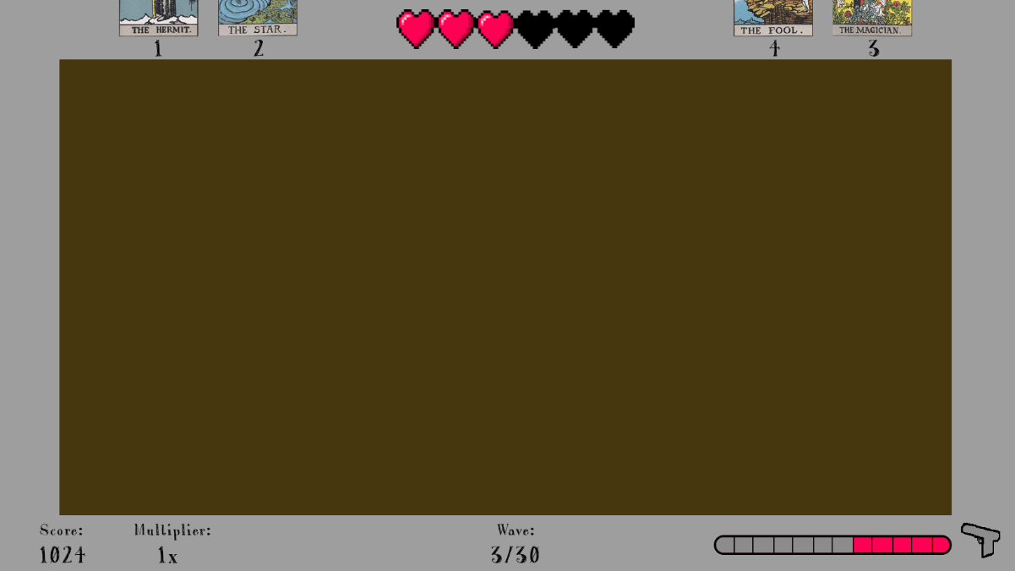

Figure 7: HUD Concept

# Appendix A – Card Effects

|  |  |  |
| --- | --- | --- |
| Card Name | Image | Effect |
| O – The Fool | C:\Users\Jake Patton\AppData\Local\Microsoft\Windows\INetCache\Content.Word\RWS_Tarot_00_Fool.jpg | Lose all your current score. Gain 4x bonus score. |
| I – The Magician | C:\Users\Jake Patton\AppData\Local\Microsoft\Windows\INetCache\Content.Word\RWS_Tarot_01_Magician.jpg | Deal 2x damage. Take 2x damage. |
| II – The High Priestess | C:\Users\Jake Patton\AppData\Local\Microsoft\Windows\INetCache\Content.Word\RWS_Tarot_02_High_Priestess.jpg | Your shots track enemies but deal half damage. |
| III – The Empress | C:\Users\Jake Patton\AppData\Local\Microsoft\Windows\INetCache\Content.Word\RWS_Tarot_03_Empress.jpg | Double the strength of each wave. Double the score each enemy gives. |
| IV – The Emperor | C:\Users\Jake Patton\AppData\Local\Microsoft\Windows\INetCache\Content.Word\RWS_Tarot_04_Emperor.jpg | Each wave contains only one enemy. |
| V – The Hierophant | C:\Users\Jake Patton\AppData\Local\Microsoft\Windows\INetCache\Content.Word\RWS_Tarot_05_Hierophant.jpg | If you die while having this effect card, the wave ends, you lose the Hierophant and are returned to full health. After reviving, you receive half score after other bonuses. This effect stacks and persists. |
| VI – The Lovers | C:\Users\Jake Patton\AppData\Local\Microsoft\Windows\INetCache\Content.Word\RWS_Tarot_06_Lovers.jpg | You control two copies of the player. Both copies move and shoot like the player and share the player’s health pool. |
| VII – The Chariot | C:\Users\Jake Patton\AppData\Local\Microsoft\Windows\INetCache\Content.Word\RWS_Tarot_07_Chariot.jpg | Each round, you spawn 4 dots which surround you and absorb hits for you. Any enemies killed by the dots don’t give you score. |
| VIII – Strength | C:\Users\Jake Patton\AppData\Local\Microsoft\Windows\INetCache\Content.Word\RWS_Tarot_08_Strength.jpg | Rather than shooting, you wield a sword, which you aim with the right stick. It instantly kills enemies it touches. |
| IX – The Hermit | C:\Users\Jake Patton\AppData\Local\Microsoft\Windows\INetCache\Content.Word\RWS_Tarot_09_Hermit.jpg | Gain 2x bonus score. You cannot buy more cards while you have The Hermit. |
| X – Wheel of Fortune | C:\Users\Jake Patton\AppData\Local\Microsoft\Windows\INetCache\Content.Word\RWS_Tarot_10_Wheel_of_Fortune.jpg | Gain a random amount of score at the end of each round. This value ranges from the total value of the wave to the negative of the total value of the wave. Positive values are 2x more likely than negative ones. |
| XI – Justice | C:\Users\Jake Patton\AppData\Local\Microsoft\Windows\INetCache\Content.Word\RWS_Tarot_11_Justice.jpg | Move 25% slower. Do 2x damage. |
| XII – The Hanged Man | C:\Users\Jake Patton\AppData\Local\Microsoft\Windows\INetCache\Content.Word\RWS_Tarot_12_Hanged_Man.jpg | Wave number does not increase. Deal half damage. |
| XIII – Death | C:\Users\Jake Patton\AppData\Local\Microsoft\Windows\INetCache\Content.Word\RWS_Tarot_13_Death.jpg | Pay half as much to buy damage upgrades. Pay twice as much to buy health upgrades. |
| XIV – Temperance | C:\Users\Jake Patton\AppData\Local\Microsoft\Windows\INetCache\Content.Word\RWS_Tarot_14_Temperance.jpg | Waves are half as strong. |
| XV – The Devil | C:\Users\Jake Patton\AppData\Local\Microsoft\Windows\INetCache\Content.Word\RWS_Tarot_15_Devil.jpg | Remove all currently held cards. Gain score equal to the cost paid for this card times the number of cards removed (plus 1 for The Devil itself). This amount is unaffected by bonuses. |
| XVI – The Tower | C:\Users\Jake Patton\AppData\Local\Microsoft\Windows\INetCache\Content.Word\RWS_Tarot_16_Tower.jpg | Your lowest upgraded stat (health or weapon level) is increased to the level of your highest stat permanently. You lose 5 score for each shot you take while you have The Tower. |
| XVII – The Star | C:\Users\Jake Patton\AppData\Local\Microsoft\Windows\INetCache\Content.Word\RWS_Tarot_17_Star.jpg | At the beginning of the round, spawn “stars” around the arena. These stars destroy enemies on contact but the player does not gain score for enemies destroyed in this way. |
| XVIII – The Moon | C:\Users\Jake Patton\AppData\Local\Microsoft\Windows\INetCache\Content.Word\RWS_Tarot_18_Moon.jpg | Enemies on the right half of the map are concealed and cannot be seen. While you are in the concealed side of the map gain 4x bonus score. |
| XIX – The Sun | C:\Users\Jake Patton\AppData\Local\Microsoft\Windows\INetCache\Content.Word\RWS_Tarot_19_Sun.jpg | The player shoots 8 shots per fire in a 360 degree arc around them. These shots do half damage rounding down. |
| XX – Judgement | C:\Users\Jake Patton\AppData\Local\Microsoft\Windows\INetCache\Content.Word\RWS_Tarot_20_Judgement.jpg | All score spent throughout the game is returned. Lose all upgrades. Skip to the final wave. After level 25, this card has no effect. |
| XXI – The World | C:\Users\Jake Patton\AppData\Local\Microsoft\Windows\INetCache\Content.Word\RWS_Tarot_21_World.jpg | Return to wave one. Lose half of your upgrades, rounding down. |

Figure 8: Card Effects Table