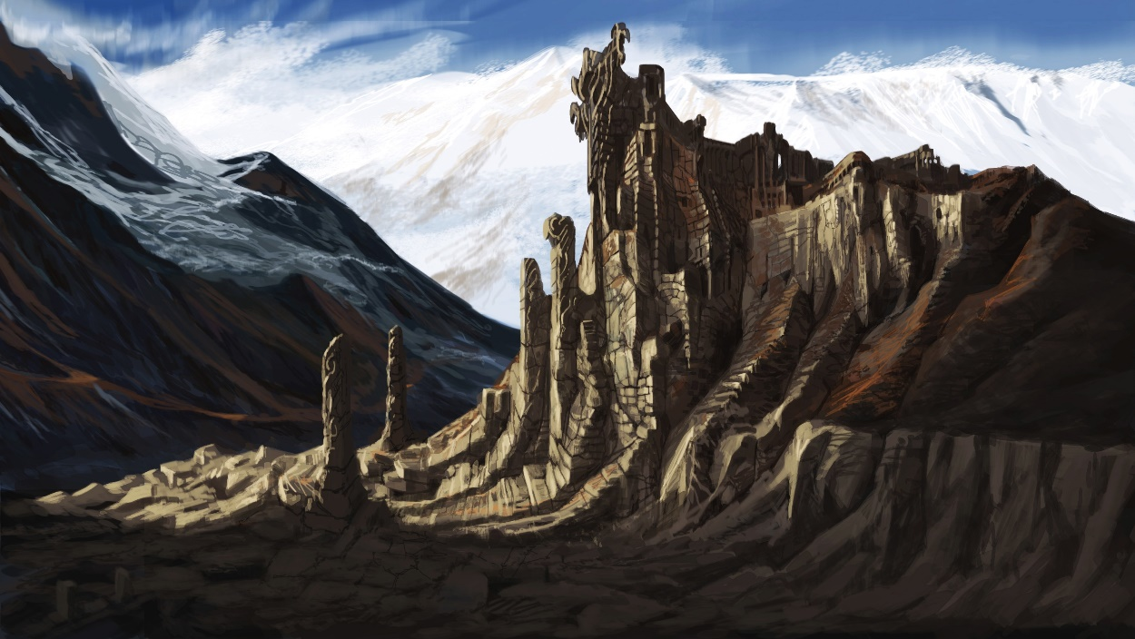

[1]

*The Elder Scrolls V - Skyrim*:   
“The Locked”

Version 1.0

|  |  |
| --- | --- |
| Designer: | Jake Patton |
| Document Date: | 6/1/2017 |
| Intended Level Delivery Date: | 7/20/2017 |

**Document Revisions Table**

|  |  |  |  |
| --- | --- | --- | --- |
| **Version** | **Description** | **Requestor** | **Date** |
| 1.0 | Initial Document | Myque Oullette | 6/1/2017 |
|  |  |  |  |
|  |  |  |  |
|  |  |  |  |
|  |  |  |  |

# Table of Contents

Table of Contents 2

Table of Figures 2

Level Information 3

Personal Goals 3

Quick Summary 3

Development Schedule 3

Level Maps 4

Floor 1 Map 4

Floor 2 Map 6

Objective(s) 8

Hook(s)/Gameplay Highlights 8

New Gameplay Mechanics 8

Campaign 8

Context 8

Backstory 8

Aftermath 9

Key Theme References 10

Architecture and Mood 10

Requirements 11

Appendix A: Quest Summary 12

Main Quest 12

Side Quest 12

References 13

# Table of Figures

Figure 2: Floor 1 Map 4

Figure 3: Floor 2 Map 6

Figure 4: Reference Sheet 10

Figure 5: Architecture and Mood Contact Sheet 10

Level Design Document

# Level Information

## Personal Goals

1. To develop a clean, Zelda-esque dungeon built around a single mechanic in *The Elder Scrolls V: Skyrim.*
2. To improve my puzzle design skills.
3. To make a portfolio-ready level.

## Quick Summary

“The Locked” is a single player level for *The Elder Scrolls V: Skyrim*. In this level, the player is tasked by a curious Breton researcher with delving into the grave of an ancient Nord king, Hamlstar Night-Scourge, to retrieve an Atmoran amulet. The primary mechanic of the tomb is a binary door system. There are colored switches littered throughout the dungeon, which, when activated, open half of the tomb’s doors while closing the other half. Eventually, the player will find a staff which allows them to activate these switches from a distance, opening parts of the dungeon which were previously inaccessible.

## Development Schedule

|  |  |
| --- | --- |
| Milestone | Date |
| LDD | 6/8/2017 |
| Whitebox | 6/15/2017 |
| Gameplay | 6/29/2017 |
| Aesthetics | 7/13/2017 |
| RTM | 7/20/2017 |

## Level Maps

### Floor 1 Map

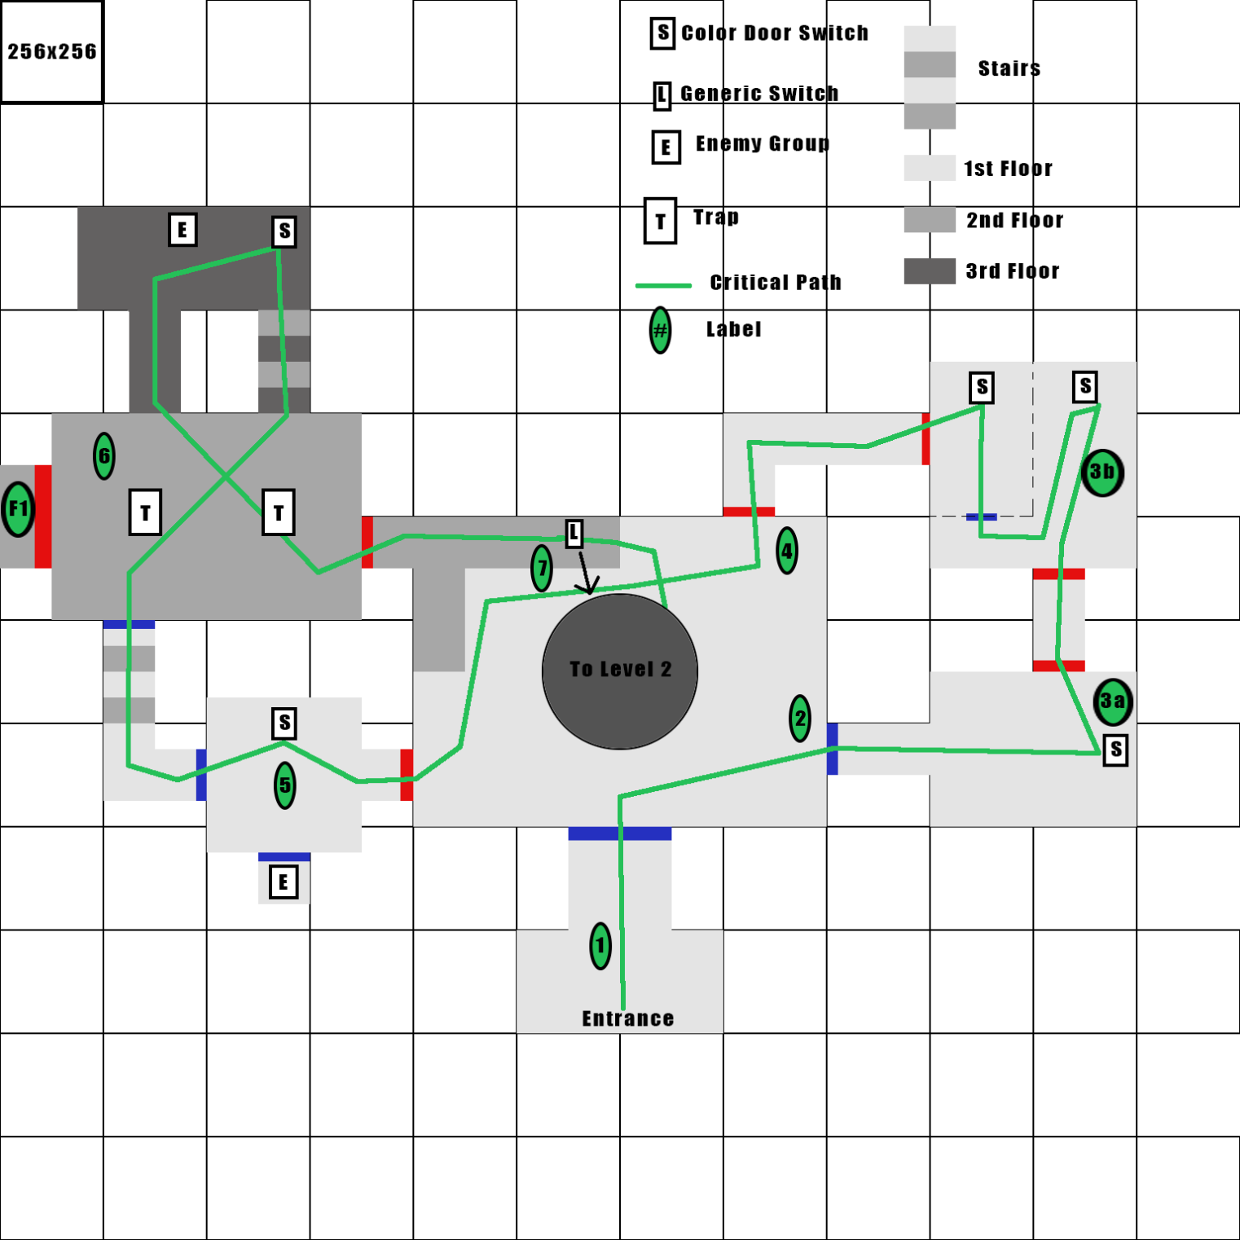

Figure : Floor 1 Map

|  |  |  |  |  |  |
| --- | --- | --- | --- | --- | --- |
| Map Label | Event Description | Detail Information | Approx. Difficulty (1-10) | Approx. Time | Wow? |
| 1 | Enter Tomb | Player enters the tomb. Blue doors are open initially. Passes into a large room | 1 | 0:10 | No |
| 2 | Exit Large Room | Player sees large room with a pit down in the center surrounded by a spike wall. All red doors are currently closed. Exits only open door (blue). | 2 | 0:40 | Yes |
| 3a | Flip First Switch | Player sees large glowing switch. After flipping it, the blue doors close and red doors open. Player learns switch mechanic. | 3 | 1:00 | Yes |
| 3b | Two Switch Room | Player reinforces switch mechanic. | 3 | 1:20 | No |
| 4 | Return to Main Room | Player returns to the main room but now red doors are open. They enter the other previously closed door. | 4 | 1:40 | No |
| 5 | Enemy Ambush | Player activates next switch but this frees a mob of enemies. Player learns that activating the switch can activate dangers | 6 | 2:10 | Yes |
| 6 | Long Distance Switch + Traps | Player must climb stairs to activate switch but on activating it the previous room floods with traps they must avoid. | 5 | 2:30 | No |
| 7 | Open Pit and Descend | Player exits on top of main room and sees a pull chain. Pull chain deactivates the spike wall and opens ramp down. Player descends to level 2. | 3 | 2:50 | Yes |
| F1 | First Optional Quest Scroll | Player must navigate more difficult trap gauntlet to get this scroll. | 6 | N/A | Yes |

### Floor 2 Map

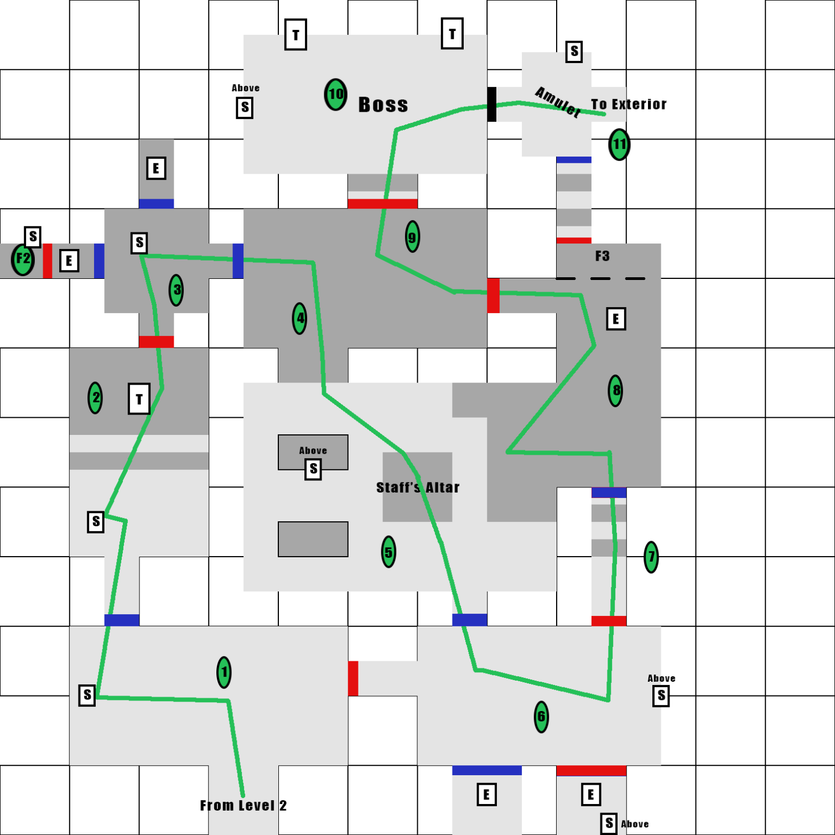

Figure : Floor 2 Map

|  |  |  |  |  |  |
| --- | --- | --- | --- | --- | --- |
| Map Label | Location Description | Detail Information | Approx. Difficulty (1-10) | Approx. Time | Wow? |
| 1 | Reach Bottom Level | Player descends into level 2. Most likely door to be open is red. Player can enter red door room but the switch in that room is too high up to activate. Can exit through blue door. | 4 | 3:30 | No |
| 2 | Player Activates Switch + Traps | Player must navigate a trap obstacle course after activating the switch. | 6 | 4:00 | No |
| 3 | Crypt Ambush | Player activates switch in 4 direction room. Activates a mass ambush. | 7 | 4:40 | No |
| 4 | Player Drops Down to Staff | Player enters boss antechamber but there is no switch in the room. The player must drop down to the room with the Architect’s Staff. | 3 | 5:00 | No |
| 5 | Architect’s Staff | This room demonstrates the staff’s powers. It can activate switches from a distance. Player must use this to escape. | 5 | 5:30 | Yes |
| 6 | Larger Crypt Ambush | Player enters room with blue doors open. Are attacked by enemies from blue door room. Must use staff to open the red doors. Then ambushed by additional enemies | 7 | 6:10 | No |
| 7 | Advanced Switch Activation | Player enters hallway but exit is blocked. Must shoot staff to opposite switch from inside hallway to switch door color. | 8 | 6:40 | Yes |
| 8 | Advanced Switch Activation 2 | Player enters balcony room. Must shoot switch in altar room from balcony to continue. | 7 | 7:00 | No |
| 9 | Reenter Antechamber | Player reenters the boss antechamber. Can now enter boss room. | 3 | 7:10 | No |
| 10 | Face Boss | Upon entering boss room, door is locked behind the player. Must fight very difficult draugr lich. Can use staff to activate traps that hurt the boss. On killing the boss, the door to his tomb opens. | 9 | 8:00 | Yes |
| 11 | Loot Tomb | Player enters treasure tomb. Large amounts of items and the quest amulet are present. Player can loot these items and then exit to the exterior. | 1 | 8:30 | Yes |
| F2 | Second Optional Scroll | Player must return with staff and solve hallway puzzle like point 7. | 8 | N/A | Yes |
| F3 | Third Optional Scroll | Same puzzle as note 7 & F2 but switch is concealed. | 5 | N/A | No |

## Objective(s)

* Main Quest: Find the Atmoran amulet hidden in the sanctum of Hamlstar Night-Scourge’s tomb.
  + Learn how to use Hamlstar’s notorious binary lock switches.
  + Find the Architect’s staff, which allows lock switches to be triggered at a distance.
* Side Quest: Find the Architect’s Scroll
  + Find the first scroll fragment on level 1.
  + Find the second scroll fragment on level 2.
  + Find the third scroll fragment after the final boss fight.

## Hook(s)/Gameplay Highlights

* Binary switch puzzles which make the player learn the layout of the dungeon intimately.
* A staff which allows these switches to be triggered from a distance, greatly increasing the complexity of these puzzles.
* A boss fight at the end of the dungeon which forces the player to put the staff to good use.

## New Gameplay Mechanics

* Binary switch doors:
  + Many of the doors in the dungeon have either a blue or red tint. There are also switches which glow either red or blue. Either all the blue or all the red doors are closed at a time. If the switch is activated, the doors which are closed open and those that are open close.
* Architect’s Staff:
  + A staff which can activate the glowing switches from a distance.

## Campaign

### Context

“The Locked” is an optional, stand alone side-mission for *Elder Scrolls V: Skyrim* designed to be completed by characters of all levels during or after the main campaign of the game. The level is not part of a larger campaign. The level involves the ancient history of Skyrim and the long dead first men, the Nords who traveled to Skyrim from their homeland of Atmora. The player is recruited for this quest on Riverwood Bridge in the southern part of the game map but the tomb they explore is in the north of the region, south of Dawnstar.

### Backstory

Professor Frassa Vettall is an expert in ancient human history in Daggerfall. She is interested in the island of Atmora, particularly why humans left the island to colonize Tamriel, and theorizes that humans left the continent because of a change in the climate that caused mass starvation. To prove this theory, she proposed an expedition to explore the tomb of an early Nordic king, Hamlstar Night-Scourge, who was said to have kept an amulet, given by his father, inscribed with the reason he left Atmora so that he would never, in a fit of homesickness, return.

Unfortunately, her proposal was rejected because of the notorious traps said to prevent the tomb from being robbed. Undaunted, she set off to Skyrim to find an adventurer who can help her. She is currently camped outside Riverwood, waiting for a suitable fortune-hunter.

### Aftermath

After retrieving the amulet, Professor Vettall finds that the inscription is mostly worn away. Nevertheless, she can read the words “Hunger […] fortune […].” She takes this as proof that her theory is correct, pays you a paltry stipend and leaves for Daggerfall.

## Key Theme References

### C:\Users\Jake Patton\AppData\Local\Microsoft\Windows\INetCache\Content.Word\ContactSheet-001.pngArchitecture and Mood

Figure : Reference Sheet

References Clockwise from Top Left:  
Lower Level Ruins [1]  
Staff Altar [2]  
Cave Wing [3]  
Snowy Ruins Wing [4]  
Exterior [5]

Figure : Architecture and Mood Contact Sheet

## Requirements

|  |  |  |  |
| --- | --- | --- | --- |
| Map Label | Description | Type | Priority |
| * | Professor Dialog (~20 lines) | Dialog | High |
| * | Switch/Door system | Scripting | High |
| * | Architect’s Staff | Scripting | High |

# Appendix A: Quest Summary

## Main Quest

1. Meet Professor Vettall at the Riverwood Bridge. She asks the player to join her in exploring a Nord Ruin.
2. After the player accepts they are teleported outside the tomb. Before and after accepting, the player may ask Vettall details about the tomb.
3. The player is first tasked with entering the tomb.
4. After the player enters the tomb, they are tasked with opening the way down into the second floor.
5. After the player removes the spike wall closing off the stairs to the second floor, the player is tasked with descending the second level.
6. After the player reaches the second level, they are tasked with finding the Architect’s Staff.
7. After finding the staff, the player is tasked with defeating the risen Hamlstar Night-Scourge.
8. After defeating Hamlstar, the player is tasked with getting the amulet.
9. Once the player gets the amulet, they are tasked with returning it to Vettall.
10. Upon returning the amulet to Vettall, the player receives their reward and completes the quest.

## Side Quest

1. After going to the tomb with Vettall, talk to her again. She asks you to find the three fragments of the Architect’s Scroll and says she will give you a reward if you do.
2. The player can find the three fragments:
   1. In the second trap room on the first floor.
   2. In the second ambush room on the second floor.
   3. In a secret hall accessed from the treasure room.
3. After collecting all three fragments, the player is directed to return to Vettall.
4. After returning to Vettall, the player receives their reward and completes the quest.

# References

[1] Adam Adamowicz, <https://www.videogamesartwork.com/games/elder-scrolls-v-skyrim/nord-ruins-1>

[2] <http://www.nexusmods.com/skyrim/mods/57784/>?

[3] <http://elderscrolls.wikia.com/wiki/Altar_of_Xrib>

[4] https: <http://megsdfgablog.blogspot.com/2013/04/initial-inspiration.html>

[5] <https://forums.dragcave.net/index.php?s=477cf5cea36092db7a0a17a436b0d233&showtopic=165035>

[6] <http://elderscrolls.wikia.com/wiki/Nordic_Tombs>